Erwin Seguinte

February 14, 2017

CSC 165

Assignment 1

To start the game please just use the “Start.bat”. This batch file runs the command:

java -jar -Dsun.java2d.d3d=false "a1.jar”

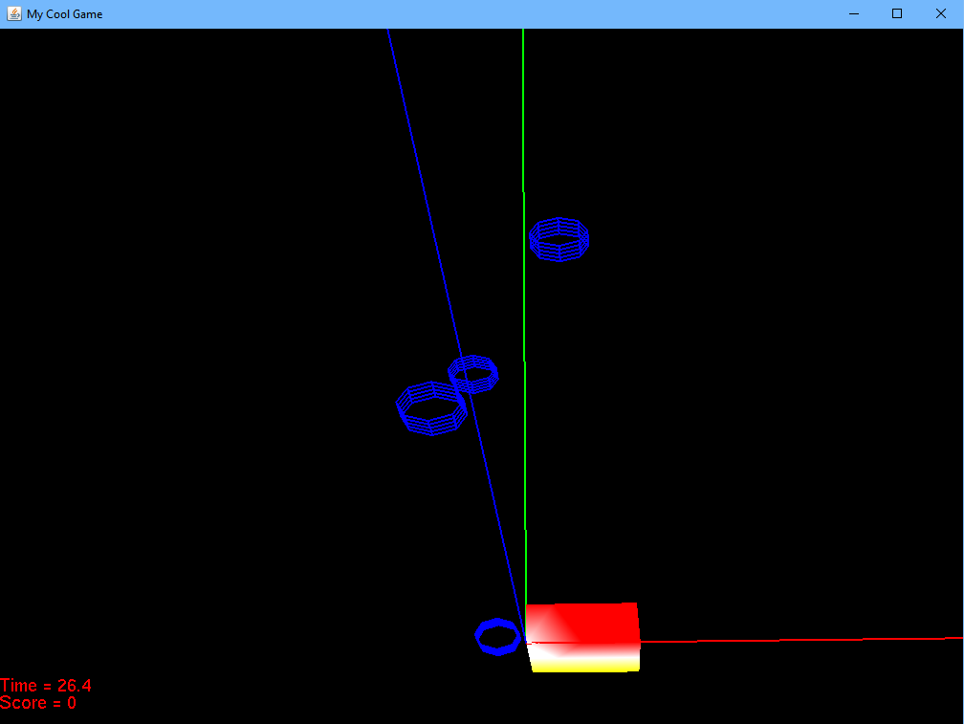

The game controls are:

* + W: Forward Camera Movement
  + S: Backward Camera Movement
  + A: Left Camera Movement
  + D: Right Camera Movement
  + Q: Left Camera Roll
  + E: Right Camera Roll
  + Arrow Up: Upward Pitch
  + Arrow Down: Downward Pitch
  + Arrow Left: Left Yew
  + Arrow Right: Right Yew
  + There is also mouse camera movement
  + Left Joystick X-Axis: Camera Movement Left and Right
  + Left Joystick Y-Axis: Camera Movement Up and Down
  + Right Joystick RX-Axis: Left and Right Yew
  + Right Joystick RY-Axis: Upward and Downward Pitch

When the camera collides with a plant (Pyramids) the score goes up by one and the plant moves into the truck.

Game Requirements:

* The game Class extends BaseGame and overrides initGame() and update().
* The model for the Cylinder is created using the sage.scene.shape class.
* The truck was created by extending the TriMesh Class and changes color.
* There are many different actions written and all controls are initialized using inputManager.associateAction().
* All basic movement was created.
* The 3 axes are displayed. X red, Y green, and Z blue.
* Two HUD items are displayed score and time.
* After a plant is collided with it moves into the truck and the truck changes to a white color for a few seconds.
* The title was updated on the game.

This was tested using an Xbox One Controller and was tested on QUAKE